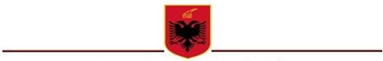

REPUBLIC OF ALBANIA

AUDIOVISUAL MEDIA AUTHORITY

PRESS RELEASE

The scheduled meeting of the Audiovisual Media Authority (AMA) was held on Tuesday, July 27th, 2021, with the participation of the following members:

Armela KRASNIQI Chairperson
Sami NEZAJ Deputy Chairperson
Gledis GJIPALI Member
Suela MUSTA Member

Upon reviewing the items of the agenda AMA decided to:

- “Approve the changes in the ownership structure of the “One Tv Vlora” sh.p.k. company licensed for “One Tv Vlora” private audiovisual subject. (Decision No. 79, dated 27.07.2021).
- “Accept the application of “Radio Maria” Association licensed for the “Radio Maria” community radio, regarding the changes of certain technical license conditions. (Decision No. 80, dated 27.07.2021).

AUDIOVISUAL MEDIA AUTHORITY

Tirana, on 27.07.2021

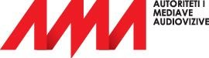
"Papa Gjon Pali II" St., No. 15, 1010, Tirana | www.ama.gov.al Tel. +355 4 2233006 | Email. info@ama.gov.al

