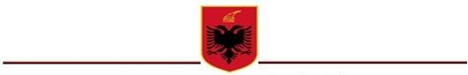

REPUBLIC OF ALBANIA

AUDIOVISUAL MEDIA AUTHORITY

PRESS RELEASE

The scheduled meeting of the Audiovisual Media Authority (AMA) was held on Friday, June 18th, 2021, with the participation of the following members:

Gentian  Sami | SALA  NEZAJ | Chairperson  Deputy Chairperson
Gledis | GJIPALI | Member
Suela | MUSTA | Member

Upon reviewing the items of the agenda AMA decided to:

- Approve the changes that have taken place in the ownership structure of “DIGIT- ALB” sh.a. company (Decision No. 74, dated 18.06.2021).
- Approve the changes in the ownership structure of the “CHANNEL 7” sh.p.k. company licensed for “TV Channel 7” subject. (Decision No. 75, dated 18.06.2021).
- Observe the invalidity of “Mariuxho” sh.p.k. company license for the “TV Bulqiza” private audiovisual subject. (Decision No. 76, dated 18.06.2021).

AUDIOVISUAL MEDIA AUTHORITY

Tirana, on 18.06.2021

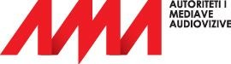
"Papa Gjon Pali II" St., No. 15, 1010, Tirana | www.ama.gov.al Tel. +355 4 2233006 | Email. info@ama.gov.al

