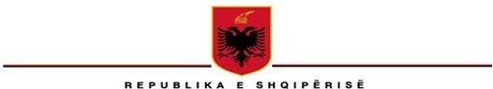

REPUBLIC OF ALBANIA

AUDIOVISUAL MEDIA AUTHORITY

PRESS RELEASE

The scheduled meeting of the Audiovisual Media Authority (AMA) was held on Wednesday, June 02th, 2021, with the participation of the following members:

Gentian  Sami | SALA  NEZAJ | Chairperson  Deputy Chairperson
Gledis | GJIPALI | Member
Suela | MUSTA | Member

AMA was informed on the Complaints Council report regarding the organization of an informative, sensibility and awareness-raising campaign on the topic “Children and Advertisement”.

Upon reviewing the items of the agenda AMA decided to:
1. Adopt an amendment to AMA decision no. 153, dated 24.12.2020, “On the adoption of the 2021 draft budget”, as amended. (Decision No. 73, dated 02.06.2021).

AUDIOVISUAL MEDIA AUTHORITY

Tirana, on 02.06.2021

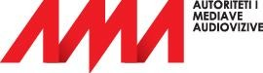
"Papa Gjon Pali II"St., No. 15, 1010, Tirana | www.ama.gov.al Tel. +355 4 2233006 | Email. info@ama.gov.al

